Guidelines for MCCC Scribes, Readers, and Examinees
The role of scribes, readers, and examinees is very important to the test accommodation process. All of these roles should be taken seriously by the persons facilitating them. The role of the scribe is to take down in writing “what is dictated by the student, no more and no less”. Readers are assigned to read tests aloud to students who may have reading difficulties. The role of the Reader is simply to read the test aloud to the student, not explain or interpret the test. The following guidelines outline the responsibilities of each of the above:

Scribes
- Scribes are expected to arrive at the testing site a few minutes before the designated test time.
- Scribes are only to write down what is dictated, no more and no less.
- Scribes should strongly suggest that student read/review what the scribe has written for each entry on the test before turning it in.

Readers
- Readers are expected to arrive at the testing site a few minutes before the designated test time.
- All exams should be read with even inflection throughout so that examinees do not receive any clues by the way the information is read. When asked, readers may reread questions as many times as necessary within the allotted testing time.
- Readers are simply to read what is written; readers should not interpret what is written.
- The reader should not answer questions from the examinee about the material he/she is reading to the student. If the student persists in asking for clarification from the reader, the reader should notify the LAL staff immediately.

Examinees
  - Examinees are not to ask the reader/scribe for answers or assistance in answering test questions. If such requests arise, the reader/scribe will notify the LAL staff and corrective measures will be taken. I the examinee persist in asking for
clarification, it may result in termination of the test.
- After the reader reads a question, the examinee must give a response, a request to reread the question, or a request to defer the question to a later time.
- The Examinee may ask the reader scribe to reread any question at the end of the test if it is within the allotted time limit.

Monitoring of the Exam
  - Monitoring of the exam will be done by an LAL staff professional. This is to ensure that the testing accommodations are being offered according to established procedures for test accommodations.
  - Unless otherwise indicated by the instructor, all tests will be closed book/not tests. All extra materials must be placed at the testing desk.

Things to Remember
- Working as a scribe, reader, or examinee is a very serious job. You are, in ways, responsible for another student’s academic progress. When interacting with students during testing, you are expected to perform your work with extreme professionalism. Joking, jesting, or inappropriate casual conversation during the test is not permitted. The student needs to have the best possible environment to complete his test.
- You are expected to arrive at the LAL before the designated test time. This will give opportunity for you to meet the student and also to receive any pertinent instructions from the LAL staff. Late arrival will result in the termination of your services.
- You are not to question the student concerning his/her disability or why he receives the services he/she does. You may ask information related to the facilitation of the test if needed (i.e. Am I reading too fast for you?).

How to receive payment for my services?
Students, who act as readers or scribes, need to contact Disability Services and fill out tax forms in the Learning Assistance Lab (Campbell Resource Learning Center C-218) as soon as they are procured for service. Readers and scribes must bring two pieces of identification to the LAL for review at this time (See hire information packet for specifics).
At the end of the semester, they should make an appointment with a Disability Counselor to confirm the hours of service for that semester.

For questions, please contact:

Disability Services Learning Assistance Lab (Campbell Resource Learning Center, C-218) (734) 384-4167
GUIDELINES FOR MCCC
- READERS
  - SCRIBES
    - 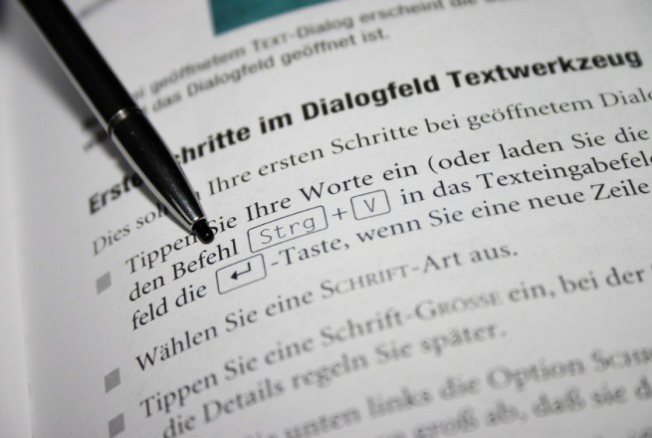EXAMINEES

MONROE COUNTY COMMUNITY COLLEGE 1555 SOUTH RAISINVILLE RD. MONROE MICHIGAN 48161-9746

